SPECIFICATION

DOCUMENT

Of

**FlyAway**

A Web Application

--------------------------------------------------------------------------------------------------------------------------------------

>>> Developer : SAI KRISHNA CHENNAKESAVULA

>>> Developer Email : [chsaikrishna6489@gmail.com](mailto:chsaikrishna6489@gmail.com)

>>> Designation : Full stack JAVA developer

--------------------------------------------------------------------------------------------------------------------------------------

**INDEX**

**1 PROJECT DETAILS 3**

* 1. Developer Details
  2. Project Specifications
  3. Product Capabilities

**2 APPEARANACE AND USER INTERACTION 4**

**3 ALGORITHM OF APPLICATION 13**

**4 FLOW CHART 16**

**5 AGILE SCRUM FLOW 17**

5.1 Step By Step Process

5.2   No: Of Sprints

5.3 Tasks Achieved

**6 GITHUB LINK 23**

**7 CORE CONCEPTS USED 23**

**DEVELOPER DETAILS:**

--------------------------------------------------------------------------------------------------------------------------

>>> Developer : Sai Krishna Chennakesavula

>>> Developer Email : [chsaikrishna6489@gmail.com](mailto:chsaikrishna6489@gmail.com)

>>> Designation : Full Stack Java Developer

--------------------------------------------------------------------------------------------------------------------------

**PROJECT DETAILS:**

--------------------------------------------------------------------------------------------------------------------------

>>> Project Name : FlyAway

>>> Project Type : Web Application

>>> Project Concept : Flight Booking System

>>> Language Used: JAVA 8

>>> Methodology Used : Agile Scrum

>>> Project Duration : 2 Weeks

>>> Project Started : 16-10-2020

>>> Project Submitted : 30-11-2020

>>> Software used : Eclipse

>>>Technologies used : JAVA EE, MYSQL, Hibernate

--------------------------------------------------------------------------------------------------------------------------

**PRODUCT’S CAPABILITIES:**

--------------------------------------------------------------------------------------------------------------------------

>>> User can book a flight.

>>> User can register and login to view previous booking history.

>>> Admin can view the master list of flights and can edit and delete them.

>>> Admin can view the master list of cities and can add and delete them.

>>> Admin can view the master list of airlines.

**APPEARANCE AND USER INTERACTION**

**The flow of web application is shown below:**

**Step 1:**  Below is the welcome page of the website.

1. In the header, we can see the logo of the website, home, link and login buttons.
2. Below the header section, we can check the availability of the flights by filling the below details.

*********************************************************************************************************

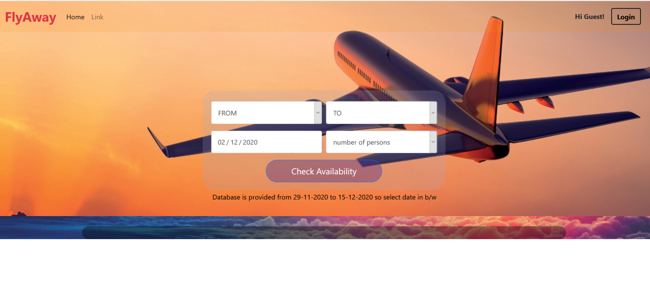

*********************************************************************************************************

**Step 2:** When we enter login page, separate login for admin and user are displayed.

*********************************************************************************************************

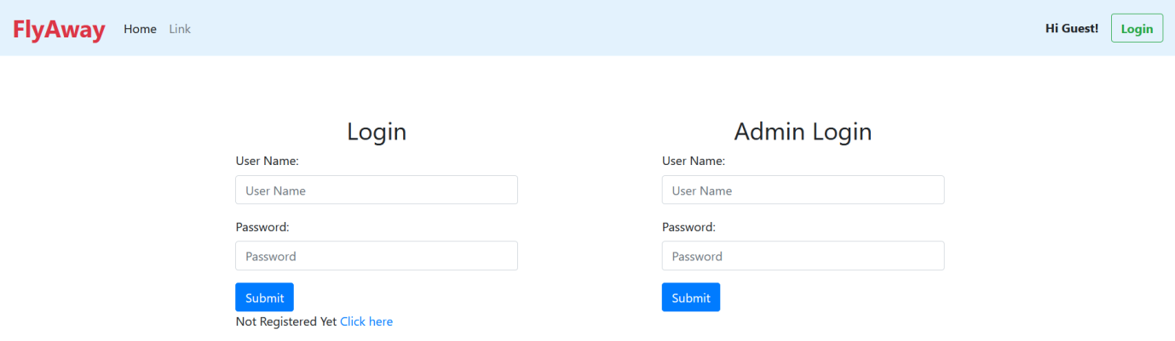

*********************************************************************************************************

**Step 3: ADMIN LOGIN:**

In admin login, admin has the prefixed username 'admin' and password ‘admin’.

*********************************************************************************************************

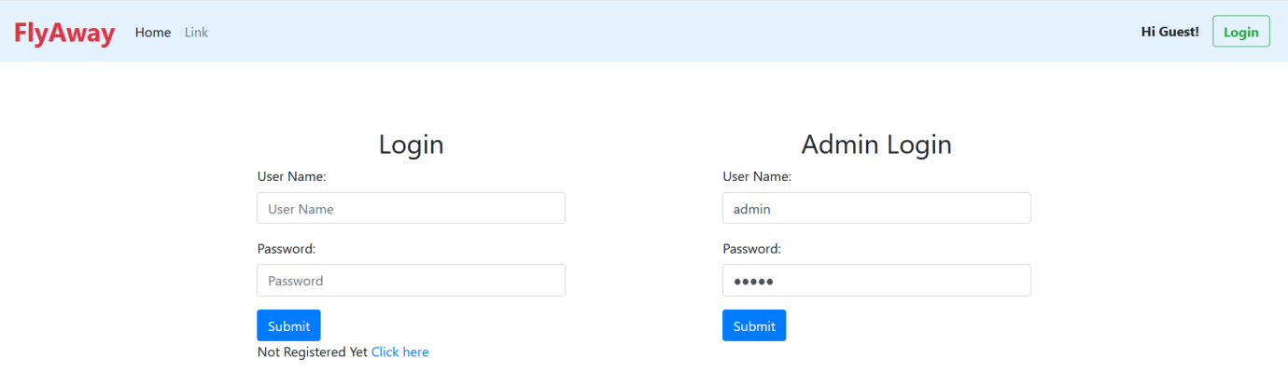

*********************************************************************************************************

**Step 4:** After admin logged in, it redirects to Admin Dashboard.

1. In Admin Dashboard, admin can view the Master list of flights, Master list of cities, Master list of airlines and change password.

*********************************************************************************************************

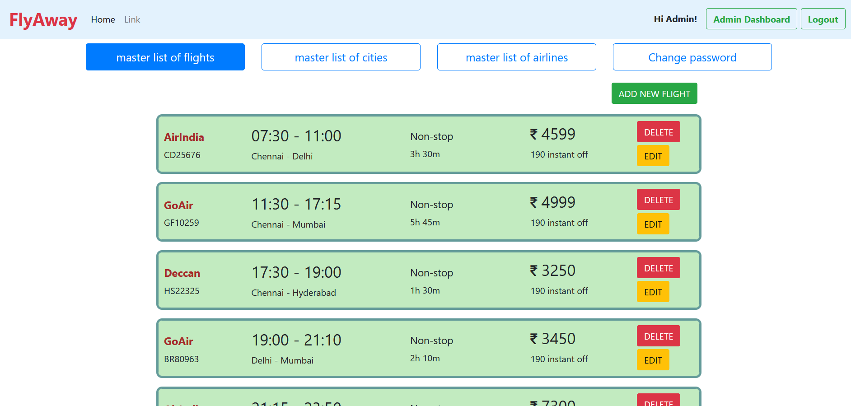

*********************************************************************************************************

**Step 5:** By entering the master list of flights, admin can view the total number of flights available.

1. The admin can delete, add new flight or edit flight details.

*********************************************************************************************************

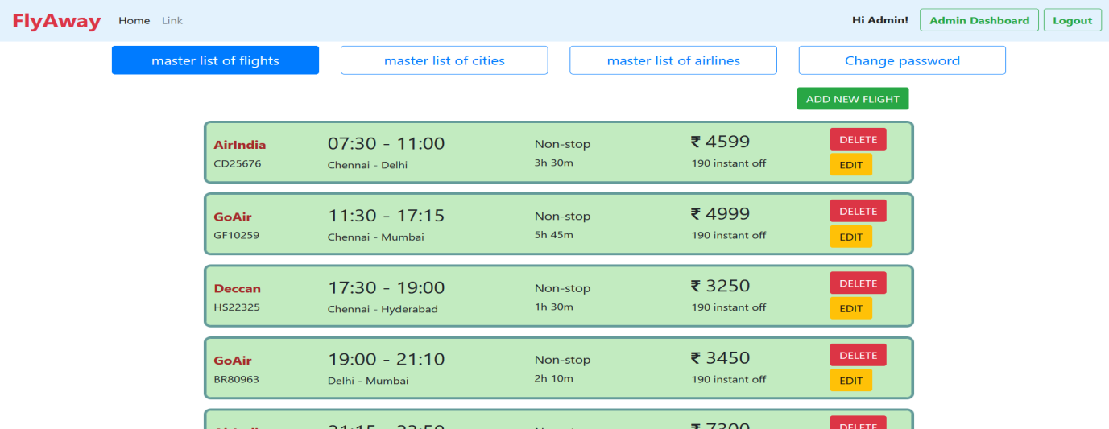

*********************************************************************************************************

**Step 6:** The admin can add new flight by filling the below details.

*********************************************************************************************************

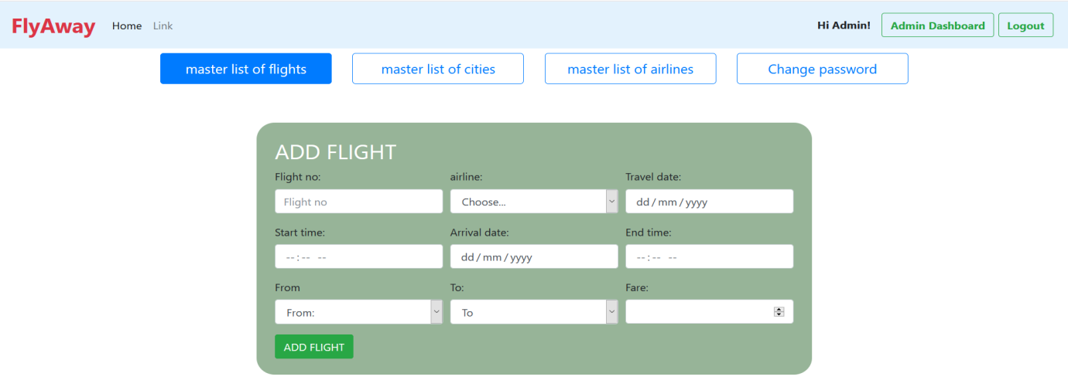

*********************************************************************************************************

**Step 7:** The admin can edit the flight details in the EDIT FLIGHT page.

*********************************************************************************************************

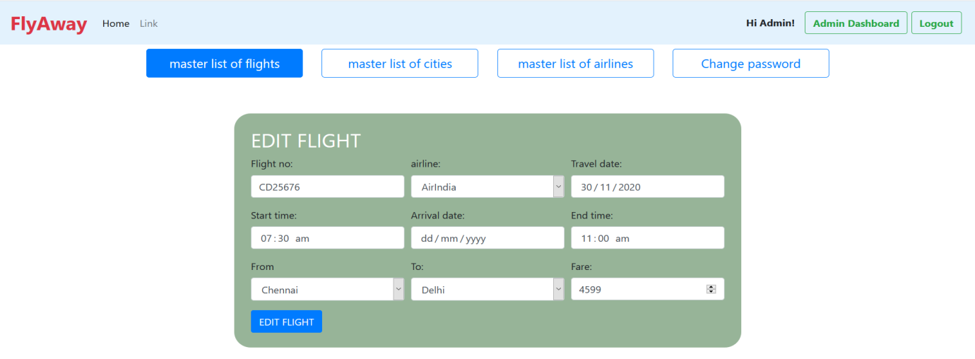

*********************************************************************************************************

**Step 8:** By entering the master list of cities, admin can view all available cities.

1. The admin can add or delete the places.

*********************************************************************************************************

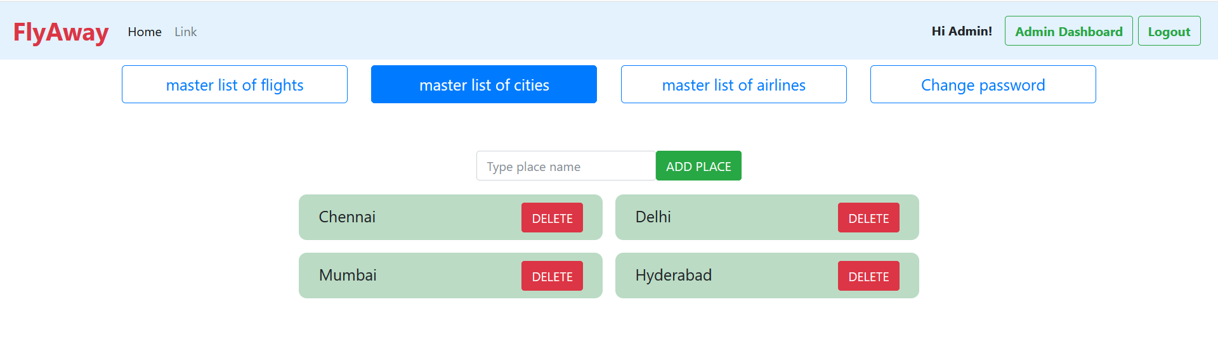

*********************************************************************************************************

**Step 9:** By entering the master list of airlines, admin can view all airlines.

*********************************************************************************************************

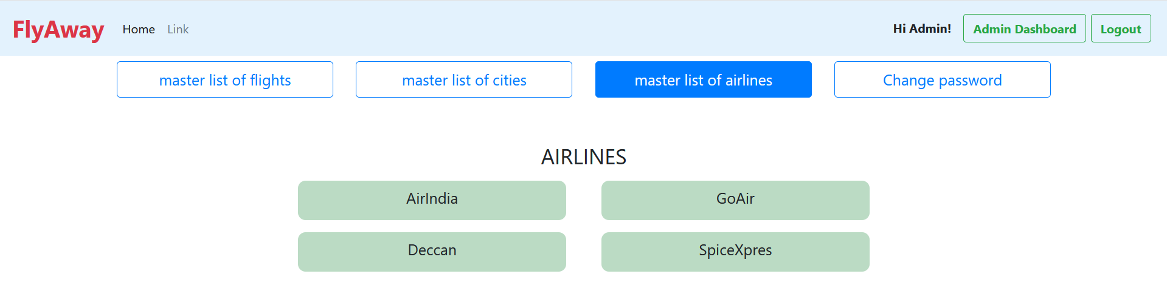

**Step 10:** The admin can change the password by entering the new password.

*********************************************************************************************************

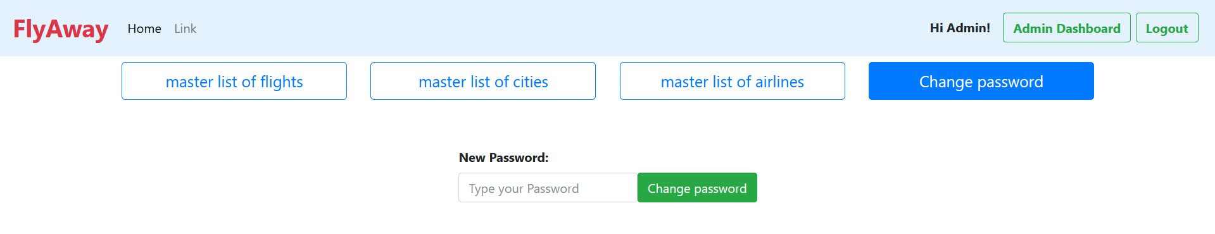

*********************************************************************************************************

**Step 11: USER LOGIN:**

  In the user login, first the user needs to register in the website.

*********************************************************************************************************



*********************************************************************************************************

**Step 12:** By clicking the ‘click here’ button, the below registration form will be displayed.

*********************************************************************************************************

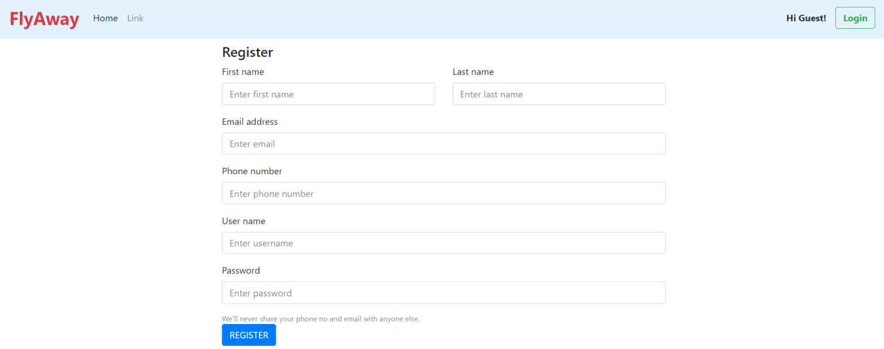

*********************************************************************************************************

**Step 13:** After user registers, it redirects to login page and displays ‘user registered successfully’.

*********************************************************************************************************

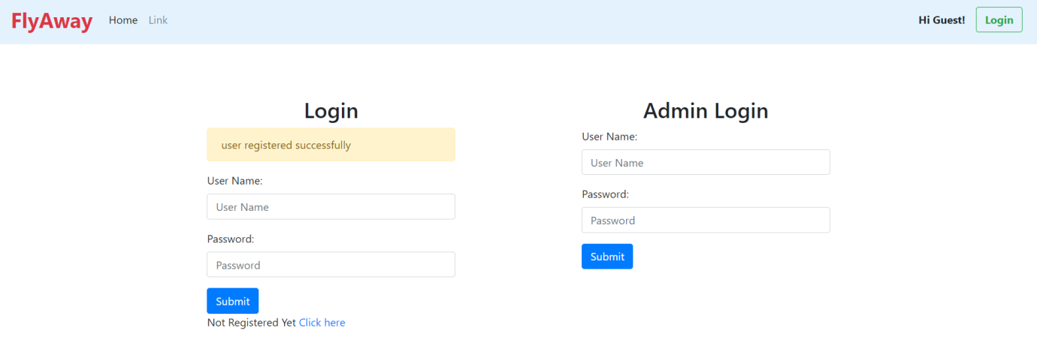

*********************************************************************************************************

**Step 14:** After user login, it redirects to the User Dashboard page.

In the User Dashboard page, it displays previous booking history and user name is displayed beside User Dashboard button.

*********************************************************************************************************

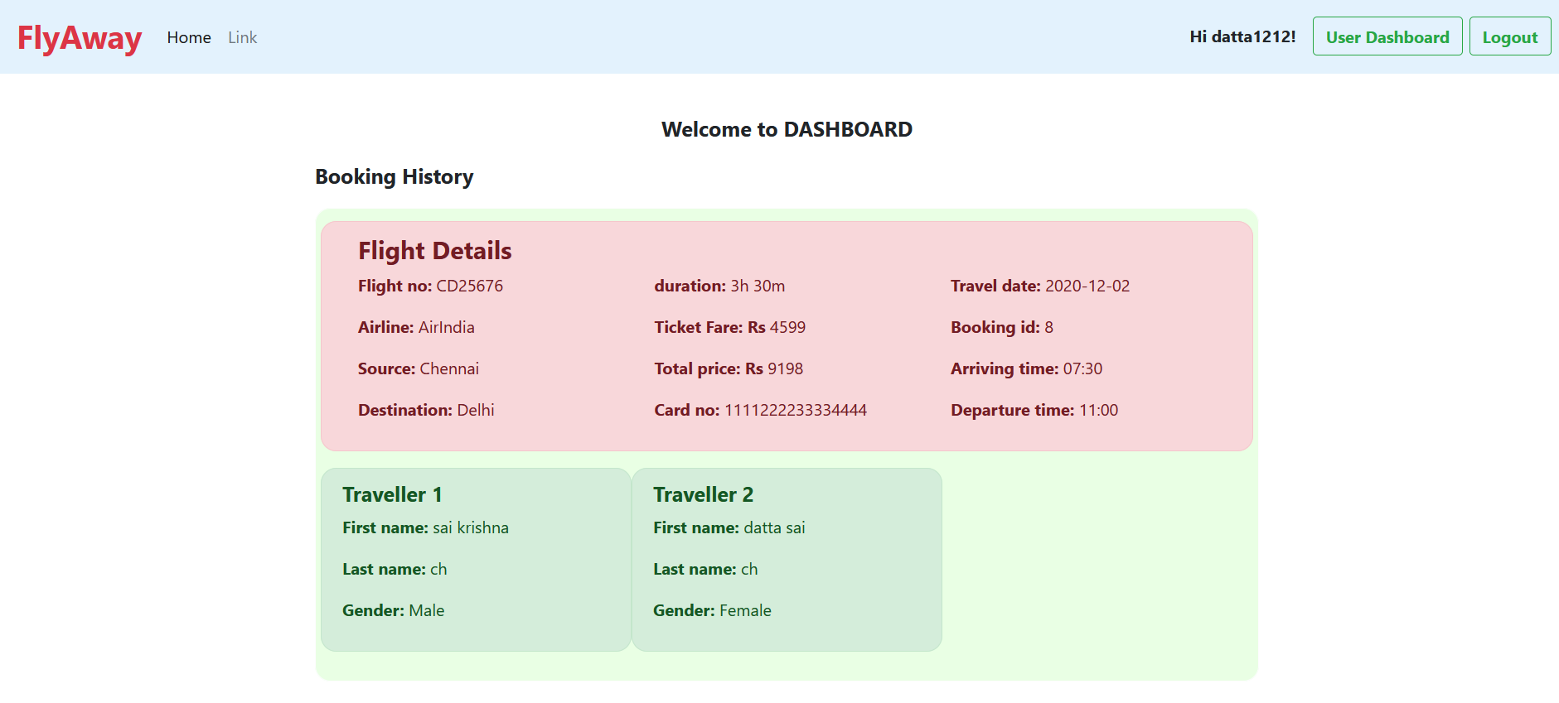

*********************************************************************************************************

**Step 15:** **BOOKING A FLIGHT:**

To check the availability of the flights, the user need to enter the below details in the homepage.

*********************************************************************************************************



*********************************************************************************************************

**Step 16:** After clicking ‘check availability’ button, the list of available flights will be displayed below.

*********************************************************************************************************

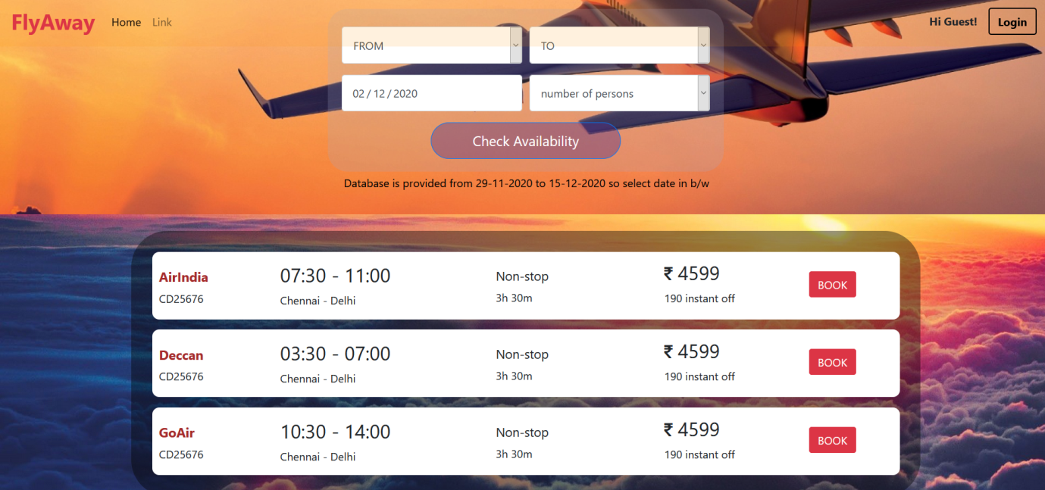

*********************************************************************************************************

**Step 17:** Select a flight by clicking on the ‘book’ button. Then the page redirects to user details form page.

1. If user is a guest user, user needs to fill all the details.

*********************************************************************************************************

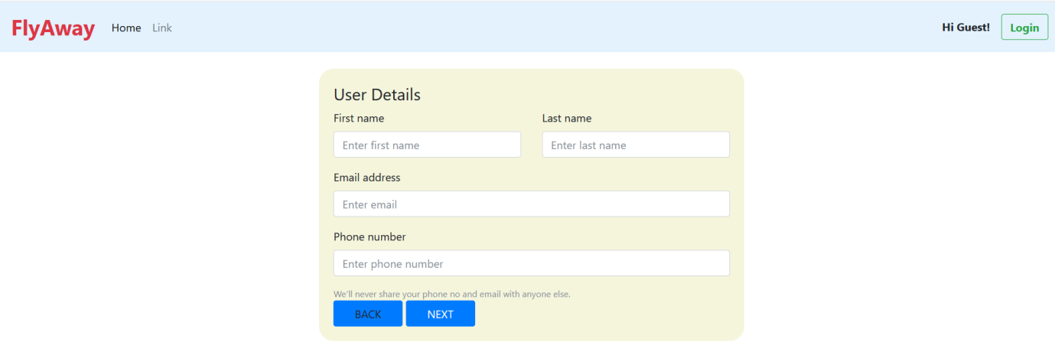

*********************************************************************************************************

**Step 18:** If user is a logged in user, the user details will be automatically filled.

*********************************************************************************************************

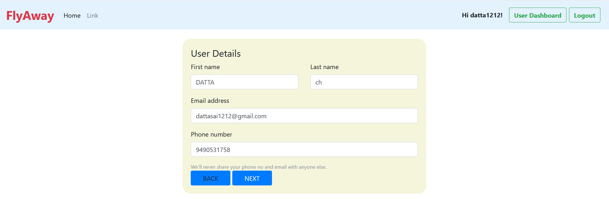

*********************************************************************************************************

**Step 19:** After submitting user details, the booking and payment form will be displayed.

*********************************************************************************************************

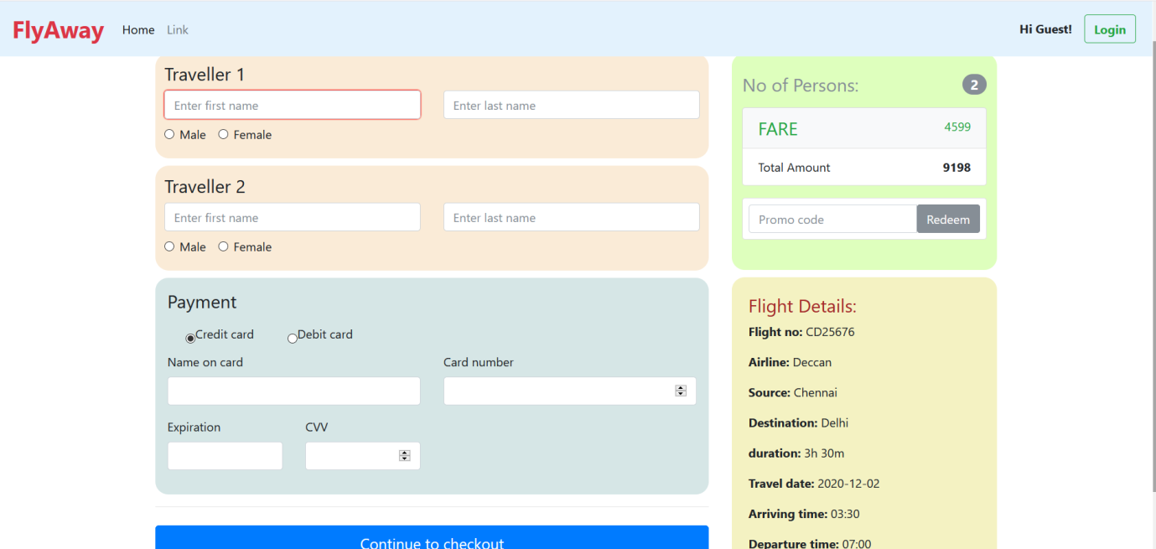

*********************************************************************************************************

**Step 20:** After submitting, traveller and payment details, booking successful page will be displayed along with booking details.

*********************************************************************************************************

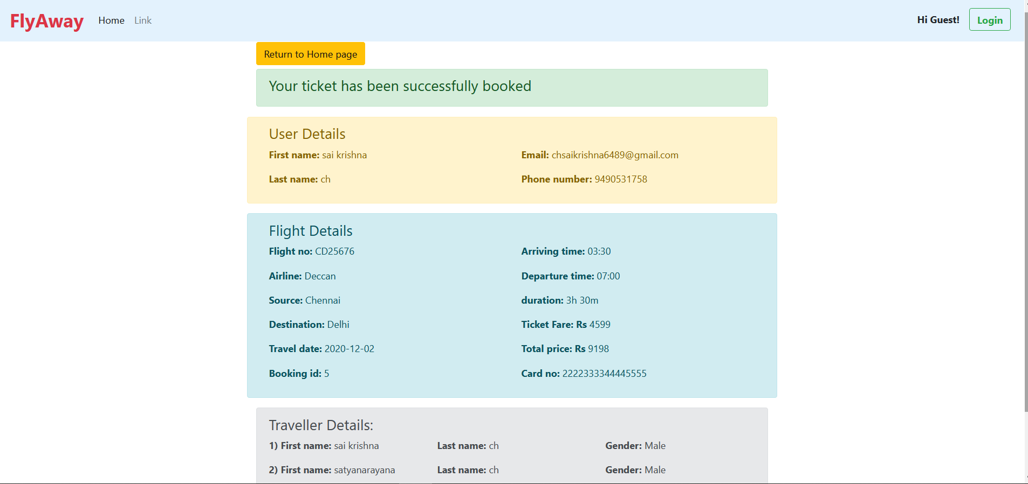

*********************************************************************************************************

**ALGORITHM OF APPLICATION**

Step-1: START

Step-2: DISPLAYS welcome page

Step-3: DISPLAYS login

DISPLAYS check available flights

Step-4:

Step-4.1: IF Admin then, GO TO Step-5

Step-4.2: IF logged in user then, GO TO Step-30

Step-4.3: IF Guest users then, GO TO Step-13

Step-5: CLICK login DISPLAYS admin login and user login forms

Step-6: INSERT admin details

Step-7: CLICK admin login

Step-8: DISPLAYS admin Dashboard

Step-8.1: To VIEW Master list of flights page, GOTO step-9

Step-8.2: To VIEW Master list of cities page, GOTO step-10

Step-8.3: To VIEW Master list of airlines page, GOTO step-11

Step-8.4: TO change password, GOTO step-12

Step-8.5: To Logout, GOTO step-33

Step-9: DISPLAYS Master list of flights

Step-9.1: To ADD flight, CLICK Add flight

Step-9.2: To EDIT flight, CLICK EDIT

Step-9.3: To DELETE flight, CLICK delete

Step-9.4: GOTO step 8

Step-10: DISPLAYS Master list of cities

Step-10.1: To ADD city, CLICK Add place

Step-10.2: To DELETE city, CLICK delete

Step-10.3: GOTO step-8

Step-11: DISPLAYS Master list of airlines, GOTO Step-8

Step-12: Step-12.1: ENTER new password

Step-12.2: SUBMIT password

Step-12.3: GOTO step-8

Step-13: Guest user

Step-13.1: TO Signup, GO TO Step - 14

Step-13.2: TO book a flight, GO TO Step - 15

Step-14: CLICK Register

Step-14.1: DISPLAYS registration form

Step-14.2: FILL the form

Step-14.3: SUBMIT the form

Step-14.4: GOTO Step 13

Step-15: DISPLAYS welcome page

Step-16: DISPLAYS flight search form

Step-17: INSERT search details

Step-18: DISPLAYS available flight list

Step-19: click BOOK on the respective flight

Step-20: DISPLAYS user details form

Step-21: CHECKS if user logged in

Step-21.1 : IF user logged in then, GO TO Step - 22

Step-21.2 : IF user not logged in or guest user then, GO TO Step - 23

Step-22: Automatically fills user details

Step-23: INSERT user details

Step-24: SUBMIT user details

Step-25: DISPLAYS booking and payment form

Step-26: FILL the details

Step-27: SUBMIT the details

Step-28: DISPLAYS booking successful page

Step-29: GOTO step-33

Step-30:

Step-30.1: TO VIEW Dashboard, GO TO Step - 31

Step-30.2: TO book a flight, GO TO Step - 15

Step-31: DISPLAYS user Dashboard page

Step-32: VIEW booking history

Step-33: Logout

Step-34: Stop

**FLOW CHART**

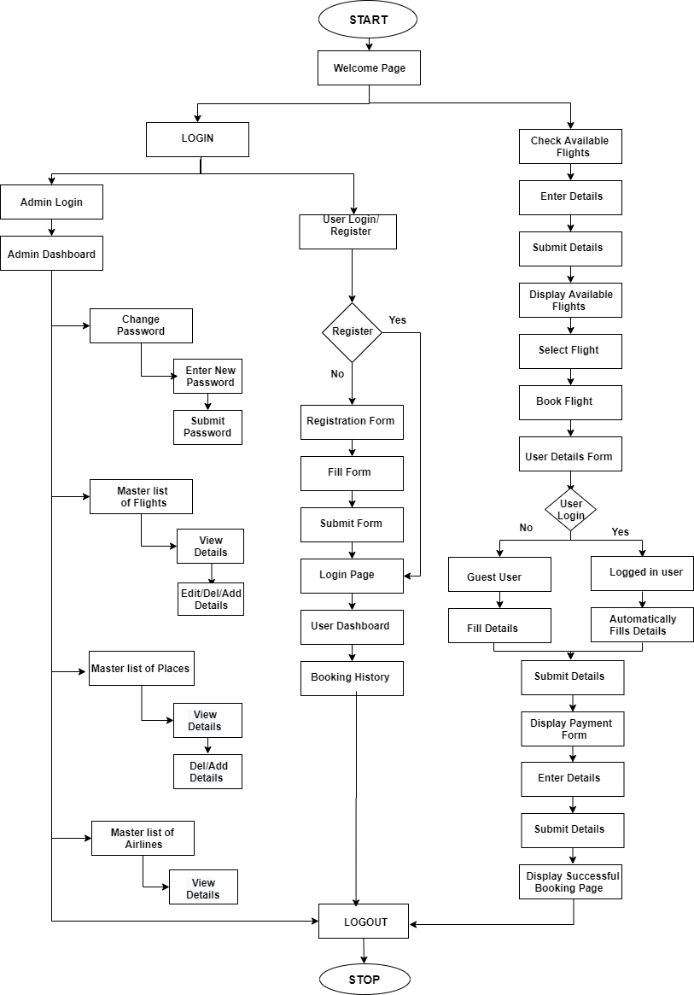

**AGILE SCRUM FLOW**

**Step-1:** started writing all user stories

Created 12 user stories

**Step-2:** made the estimation of all the user stories

Estimated for all the 12 user stories

**Step-3:** prioritised the user stories

**Title: Welcome Page**

**Priority:** high

**Size: 4**

**As a** user

**I want to** display a check availability and login button

**so that I can** login and check available flights easily

**Title: Login Page**

**Priority:** high

**Size: 4**

**As a** user

**I want to** have different logins for admin and user

**So that I can** login separately

**Title: Signup Form**

**Priority:** low

**Size: 5**

**As a** user

**I want to** display a registration form

**So that I can** register

**Title: Dashboard**

**Priority:** high

**Size: 5**

**As a** user

**I want to** have different dashboards for user and admin

**So that I can** view separately

**Title: Admin**

**Priority:** high

**Size: 2**

**As a** Admin user

**I want to** display total flight details, places and airlines

**So that I can** add/delete/view flight, places and airlines details

**Title: Admin change password**

**Priority:** low

**Size: 6**

**As a** Admin user

**I want to** change password

**So that I can** reset the password

**Title: Booking History**

**Priority:** low

**Size: 2**

**As a** user

**I want to** display booking history

**So that I can** know my previous bookings

**Title: User Details Form**

**Priority:** low

**Size: 6**

**As a** user

**I want to** display details separately

**So that I can** save my time

**Title: Guest User Details Form**

**Priority:** low

**Size: 2**

**As a** guest user

**I want to** display unfilled form

**So that I can** fill the form

**Title: Booking and Payment Form**

**Priority:** high

**Size: 6**

**As a** guest user

**I want to** display traveller and payment form

**So that I can** fill my details

**Title: Success page**

**Priority:** high

**Size: 2**

**As a** user

**I want to** display success page

**So that I can** see the flight is successfully booked with details

**Title: Logout**

**Priority:** high

**Size: 6**

**As a** user

**I want to** display logout button

**So that I can** logout from my account

**Step-4:** selected the user stories and divided it into 21 tasks

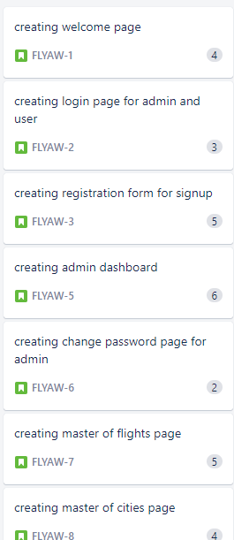 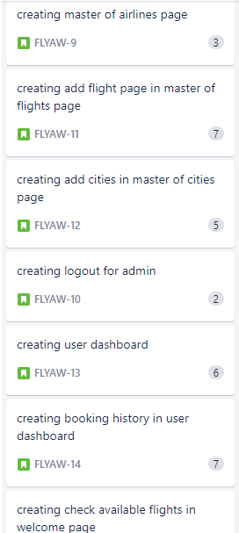

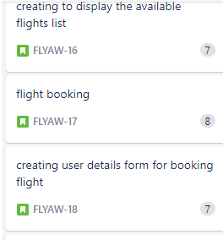 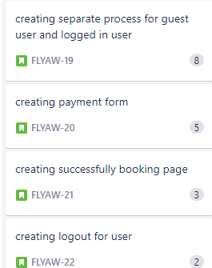

**Step-5:** created two sprints of each 1 week duration and allocated the tasks to

sprint1

**Step-6:** sprint1 started

In sprint1 we have 14 tasks

 

At the end of sprint, I had reviewed the sprint, I had completed 12 tasks and also tested and 13th and 14th tasks was in progress

So added 13th and 14th tasks to the sprint2

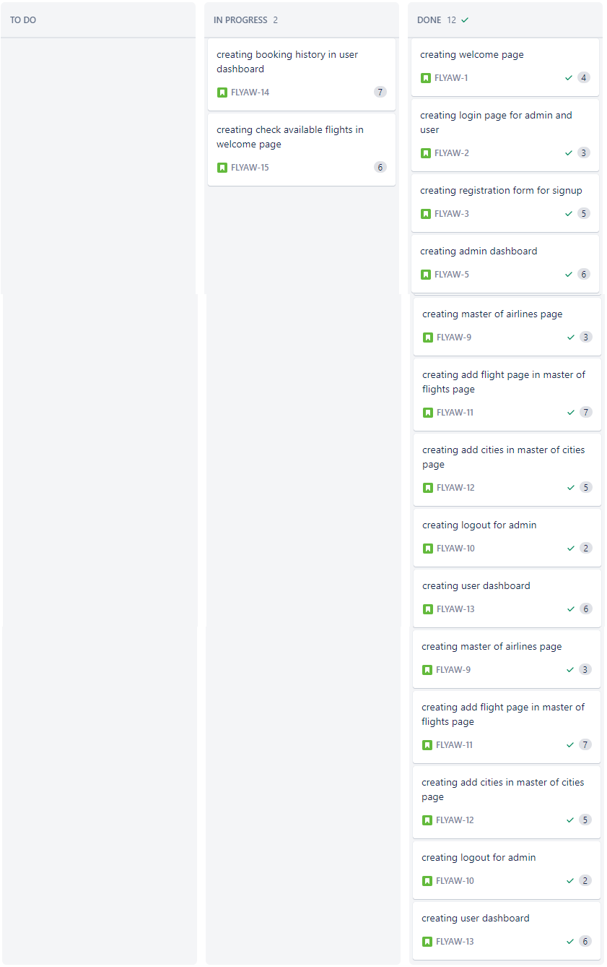

**Step-7:** sprint2 started

In sprint2 we have 7 tasks and 2 tasks from sprint1 that is total 9 tasks.

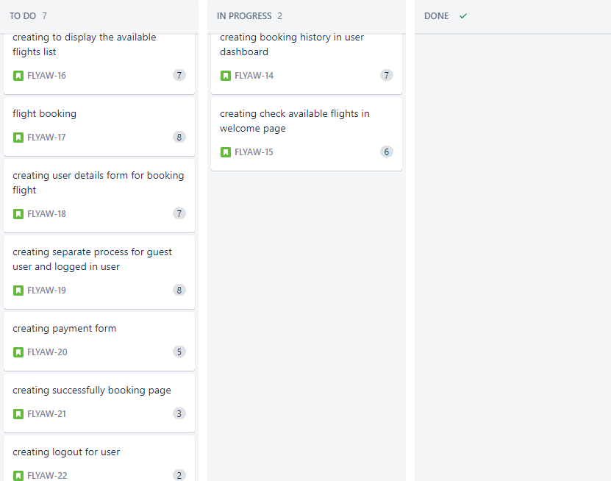

At the end of the sprint, I had reviewed the sprint; I completed all the 21 tasks successfully and tested.

**Step-8:** the project is completed and tested and finally released

**SPRINTS PLANNED:** 2

**TASKS ACHIEVED:** Created JSP pages for

1) Welcome page which displays flight search form

2) Login page for admin and user 3) Dashboard page for admin and user

4) Signup form for user registration 5) Admin page and user page

6) Admin change password 7) Booking history of user 8) User details form

9) Guest user 10) Booking and payment page for book and payment

11) Success page for successfully 12) Logout page

**GITHUB LINK:**

https://github.com/saikrishna6489/simplephase2.git

**CORE CONCEPTS USED:**

SERVLETS

HIBERNATE

INHERITENCE

JSP

JSTL TAGS

ENCAPSULATION

EXCEPTION HANDLING

COLLECTIONS